This template has been developed by Kidney Health Australia to assist in the management of patients with chronic kidney disease. It is designed to be used in conjunction with the Chronic Kidney Disease Management in Primary Care, 5th edition handbook available at http://www.kidney.org.au/ckdhandbook and to be edited to suit individual practice.
Detection of Chronic Kidney Disease

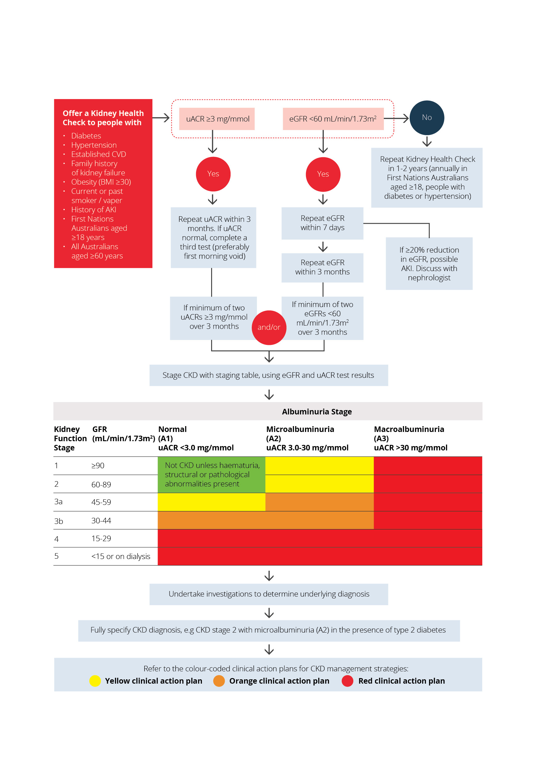
This template uses colour-coded actions relevant to your patient’s stage of CKD.
Refer to pp26-28 CKD Management in Primary Care, 5th edition handbook for further information
Date of Plan: | Review Date:
Patient Name / ID: | Date of Birth:
GP Name: | GP Phone:

Please follow the colour-coded action plan relevant to your patient’s stage of CKD.
Refer to pp 30-34 CKD Management in Primary Care, 4th edition handbook for further information

CLINICAL ACTION PLAN
YELLOW  eGFR >60mL/min/1.73m2  with microalbuminuria (A2)  or  eGFR 45-59mL/min/1.73m2  with normoalbuminuria (A1) | ORANGE  eGFR 30-59 mL/min/1.73m²  with microalbuminuria (A2)  or  eGFR 30-44 mL/min/1.73m² with normoalbuminuria | RED  Macroalbuminuria (A3) irrespective of eGFR  or  eGFR < 30 mL/min/1.73m² irrespective of albuminuria
MANAGEMENT GOALS
- Slow progression of CKD – slow eGFR decline – Reduce albuminuria by at least 30%.  - Assess and lower cardiovascular risk.  - Avoid nephrotoxic medications or volume depletion.  - Encourage positive lifestyle changes and self-management practices. | - Early detection and management of complications.  - Adjustment of medication doses to levels appropriate for kidney function.  - Appropriate referral to a Nephrologist when indicated. | - Prepare for kidney replacement therapy if appropriate.  - Prepare for comprehensive conservative care if appropriate.
FREQUENCY OF REVIEW
Every 12 months | Every 3 – 6 months | Every 1 – 3 months

Patient needs/ relevant conditions | Goals- changes to be achieved | Required treatments & services including patient actions | Arrangements for treatments/ services (What, who) | Review, changes made on Date:
1. Kidney Health Check, Haematuria & Imaging
eGFR (See P17, CKDM handbook)
Current Results  _____________  mL/min/1.73m² | Minimise deterioration by managing CVS risk factors & medications | For diagnosis of CKD, decrease eGFR must be present for at least 3 months | GP to monitor | Review Due:  __ /__ /__
 |  |  |  | 12 mths
 |  |  |  | 6-12 mths
 |  |  |  | 1-3 mths
Urine ACR (See P18, CKDM Handbook)
Current Results  ____________  mg/mmol | Target: 50% reduction in urine ACR  Albuminuria present if urine ACR >3 mg/mmol (A2-A3)  Minimise progression with ACEi/ ARBs (see P33 CKD handbook) | - First morning void minimises postural effect on albumin excretion  - If microalbuminuria and age >40 screen for myeloma | GP to monitor | Review Due:  __ /__ /__
 |  |  |  | 12 mths
 |  |  |  | 6-12 mths
 |  |  |  | 1-3 mths
Blood pressure (See pp33-36 & 52-56 CKD handbook)
Current results  ____ /____  mmHg | Target:  ≤ 130/80 mmHg  Or lower if tolerated | - Lifestyle modification  - +/- Medication  - Screen for sleep apnoea – a significate cause of refractory hypertension | GP to monitor | Review Due:  __ /__ /__
 |  |  |  | 12 mths
 |  |  |  | 6-12 mths
 |  |  |  | 1-3 mths
Imaging
Evaluate kidney tract | Ultrasound scan |  | Consider need for referral
Bone Health
Bone health  If eGFR < 45  and/ or age > 70 | Screen for osteoporosis | - Bone Mineral Density | Consider medication & allied health input | 2 yearly
Haematuria (See pp62-63 CKD handbook)
Haematuria | Screen for & determine significance of | - Dipsticks are sensitive and accurate.  - Evaluate further if 1+ or more. | Depends upon result | Initial assessment then annually
2. Laboratory assessments
Biochemical Profile
Including urea, creatinine, and electrolytes
Biochemical profile | Monitor for changes, electrolyte disturbances etc. |  | GP/ Nurse | Review Due:  __ /__ /__
 |  |  |  | 12 mths
 |  |  |  | 6-12 mths
 |  |  |  | 1-3 mths
Glycaemic Control (for people with diabetes) (see Chapter 3 CKD handbook)
HbA1c  ____________  mmol/mol | Target:  HbA1c: Generally: ≤53 mmol/mol (range 48-58); ≤7% (range 6.5-7.5).  Needs individualisation according to patient circumstances | - Lifestyle modification  - +/-Medications for Diabetes | GP/ Nurse | 3-6 monthly review of Diabetes
Lipids (see P65 CKD handbook)
Fasting lipid profile  TC:__________  HDL:_________  LDL:_________  TG:__________  HDL/TC:______ | - In adults with newly identified CKD, evaluation with a fasting lipid profile is recommended. | - Consider lipid lowering therapy | GP/ Nurse | Follow up measurement as per GP
Full Blood Count
Calcium and Phosphate
Parathyroid Hormone
3. Medications
Nephrotoxic drugs (see pp33-36 CKDM handbook)
Review renally excreted medications  Avoid Nephrotoxic Medications | Adjust medication doses to levels appropriate for kidney function (Dosage reduction or cessation of renally excreted medications is generally required once the GFR falls below 60 mL/min/1.73m²)  Patient understands the importance of avoiding drugs that can adversely affect kidney function (e.g., NSAIDs, radiographic contrast agents) | Medication Review  Patient Education | GP / Pharmacist | When any new medication prescribed, or supplements considered
Medication review
Referral for an HMR (item 900) if indicated | Correct use, dosage, of medications to reduce hospital admissions and side effects | Patient education  Referral to community pharmacist | GP / Pharmacist to review & provide education | HMR annually if eligible
4. Referral
Referral to Nephrologist (see p74 CKDM handbook)
Consider if referral to a Nephrologist is warranted | The individual’s wishes and comorbidities should be taken into account when considering referral.  Recommended Tests prior to referral  - Current Blood Chemistry and haematology  - Urine ACR and urine microscopy for red cell morphology  - Current and historical blood pressure  - +/- Kidneys Ureters Bladder ultrasound |  | GP / Nephrologist | Review at each GPMP review
5. Other assessments
Absolute Cardiovascular Risk (see P8-9 CKDM handbook) **Discussion Point**
Current Risk is:  ⃝ Low  ⃝ Moderate  ⃝ High | www.cvdcheck.org.au  High: Greater than 15% Risk of cardiovascular disease within next five years  Moderate: 10-15% risk of cardiovascular disease within next five years  Low: Less than 10% risk of cardiovascular disease within next five years  Refer p48 CKD handbook for guidance on when the tool should not be used | Provide lifestyle and pharmaceutical management strategies if indicated based on the patients’ risk level and clinical judgement.
6. Lifestyle modification see pp29-32 CKD handboook
Smoking/ vaping
Smoking status  ⃝ Current  ⃝ Former  ⃝ Non-smoker | Smoking cessation | (QUIT Line 137848)  Consider available medications/ tools | Patient &  GP to manage collaboratively
Nutrition
Current Dietary Habits:  ___________ | eGFR <30 mL/min/1.73m²  Individualised diet intervention/ treatment targets involving Accredited Practicing Dietitian (APD)  See Australian Dietary Guidelines | Referral to Accredited Practicing Dietitian  Patient education (list resources, assistance given) | GP to monitor  Referral to Accredited Practicing Dietitian for TCA
Alcohol intake
Current Alcohol intake:  ____ standard drinks per week  ____ alcohol free days per week | Limit to < 2 standard drinks/day  And 2 consecutive alcohol-free days/ week | Patient education  http://www.alcohol.gov.au/internet/alcohol/publishing.nsf/content/standard | Patient to manage  GP to monitor
Physical activity
Current Physical Activity regime:  ____________ | Aim for 2.5-5 hours of moderate intensity activity across the week. | Patient exercise routine/ personal goals | Patient to implement  Referral to exercise physiologist for TCA
Weight management
Current Measurements:  Weight  ________ kg  Waist Circumference  _________ cm  BMI  _______ kg/m² | Targets:  Weight: __________kg  Waist circ: ________cm  BMI: ____________kg/m²  Ideal weight should be BMI < 25 kg/m² and waist circumference < 94 cm in men (< 90 cm in Asian men) or < 80 cm in women (including Asian women) | Monitor waist & weight/ personal goals | Patient to monitor  GP/Nurse to review  Referral to exercise physiologist, weight management group | Review Due:  __ /__ /__
 |  |  |  | 12 months
 |  |  |  | 6-12 months
 |  |  |  | 1-3 months
7. Patient support
Patients understanding of CKD)
Patient’s understanding of chronic kidney disease  & the suspected cause of their CKD | Provide information about chronic kidney disease & patient’s role in management of their condition | Patient education (list resources, assistance given)  ⃝ Kidney Health Service - 1800 454 363 | GP/ Nurse |  | Review patient understanding with each GPMP/ TCA review
Multi-chronic conditions
List other chronic conditions:  1)  2)  3) | Patient has a good understanding of their chronic conditions and how they interrelate with CKD | Patient education (list resources, assistance given)  Screen for sleep apnoea  Screen for depression | GP/ Nurse |  | As required
Self-management
Discuss how self-management can improved outcomes | - Set achievable goals  - Sharing your care with you GP  - Ask the right questions  - Manage your chronic condition(s)  - Access relevant support services | - Self-Management Course  - Patient information and education www.kidney.org.au  - Kidney health information service 1800 454 363

Team Care Arrangements
Allied Health Provider type | Reason for inclusion in GPMP | Name of provider | Provider Phone Number | No. of visits  5 in total / calendar year | Agreed to TCA  Yes/no

8. Common CKD complications / considerations
Special Issues in the elderly (see p38 CKDM handbook)
Consider issues related to:  - Appropriate referral  - Management of cardiovascular risk  - Medication considerations  - Shared decision making | Care of elderly patients with CKD requires an individualised approach to address comorbidities, together with variability in functional status, life expectancy and health priorities | As for general CKD but modify to patients’ particular circumstances. Screen for postural hypotension.  Consider need for ACAT, EPOA, Advanced Health care Directive
Patients CKD complications (see chapter 4 of CKD Handbook)
(more common once eGFR < 30 mL/min/1.73m²)
Delete any of the CKD complications that are not relevant from the table below | List relevant goals / targets | List required treatments & services including patient actions | Arrangements for treatments/ services (What, who) | Review according to recommendations in CKDM handbook
Acidosis |  | Supplementation with sodium bicarbonate
Anaemia | Hb 100-115g/L |  | Patient information on KHA website
Cognitive decline
Depression

Haematuria

Hyperuricaemia
Hyperkalaemia | K+<6.0 mmol/L
Lipids
Malnutrition |  | Refer to Accredited Practicing Dietitian
Mineral and bone disorder
Muscle cramps
Oedema
Pain management
Pruritus
Restless legs |  | - Check iron status and replace if deficient  - Home therapies such as massage, warm baths, warm/cool compresses, relaxation techniques, exercise  - Dopaminergic agents or dopamine agonists  - Benzodiazepines
Sleep apnoea |  | - Weight reduction  - Avoid central nervous system depressants (including alcohol)  - Assess with Sleep study
Uraemia |  | - Dialysis should be commenced as soon as uraemic symptoms develop
Support & treatment options
Treatment options for stage 5 CKD (if appropriate) | - Patients and their families or carers should receive sufficient information and education regarding the nature of Stage 5 CKD, and the options for the treatment to allow them to make an informed decision about the management of their condition.  - Treatment choice has more effect on lifestyle than it does on mortality or morbidity.  - A shared decision-making approach is highly recommended. | Patient education (list resources, assistance given) | GP/ Nurse/ Nephrologist/ Renal Unit Staff
GP Name: | Date:
GP Signature:
Patient Name: | Date:
Patient Signature:

