


Quality Improvement PDSA Guide

Chronic Kidney Disease

MODULE
Version 1 | June 2022

Plan, Do, Act, Study
The Plan, Do, Study, Act (PDSA) cycle is a systematic series of steps for gaining valuable learning and knowledge aimed at the continual improvement of a product or process. It is used in implementing a planned improvement or change by breaking down into smaller manageable parts and testing each change to make sure things are improving and no efforts are wasted.
PDSA can be used to test suggestions for improvement easily, based on existing ideas and research or through practical ideas that have been proven to work elsewhere. It is a cyclical model because the benefit is not always achieved in one cycle, which means the process can be refined and the cycle repeated.

GPs:
- Select a leader to facilitate the activity. Identify the members of the group by completing an enrolment form.

- Undertake a planning and development meeting. GPs should discuss the following questions and record the responses:
- What are we trying to accomplish?
- How will you know that a change is an improvement?
- What change can we make that will result in improvement?

- Carry out the first PDSA cycle.

- Develop the second and subsequent PDSA cycles as required.

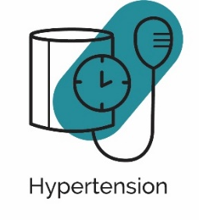
Why CKD?
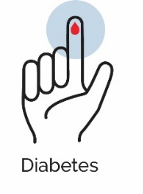
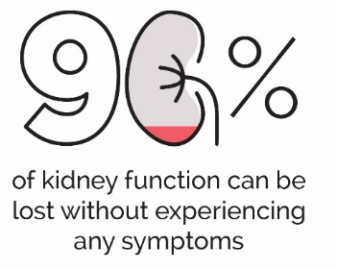

and are over 50% of all causes of CKD.

People with CKD are at high risk of cardiovascular disease and people with cardiovascular disease need to have a Kidney Health Check every 1-2 years.

Plan
- Hold a practice meeting to discuss the aims and outcomes of the first PDSA cycle.
- Plan in detail, the steps involved in the first cycle.
- Plan how to best implement the initiative in clinical practice.
- Pull reports from practice software following the How to guide ‘How to search for evidence of CKD using PENCAT’ to determine:
- Active adults with indicated CKD and no diagnosis (numbers)
- Active adults with diagnosed CKD & coded (numbers)
- Active adults with results for eGFR <60 mL/min/1.73m² (numbers)
- Active adults with results for test results for Urine ACR >3 mg/mmol (numbers)
- Active adults in each stage of CKD
- Analyse the diagnosis gap – (coded CKD numbers and numbers of patients with evidence of CKD)
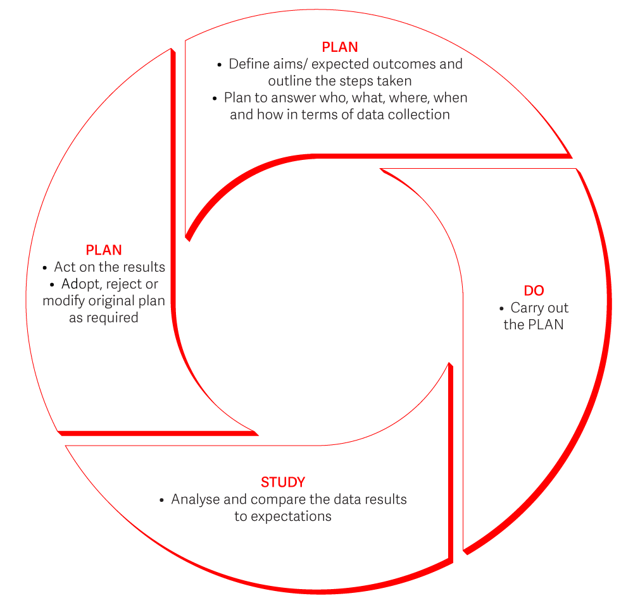
- Generate a list of people needing a review of their CKD diagnosis (generate a report card per GP)
ACT
- Complete a PDSA Planning Document.

Do
- Implement the steps you have identified in your PLAN to detect people at who might have chronic kidney disease and perform Kidney Health Checks.
- Document
- Utilise Kidney Health Australia Practice Tool Kit
- Use ‘How to Guides’ to assist in practice system changes
- Identify, stage and code any new CKD diagnoses and manage per CKD Management in Primary Care handbook or CKD-Go! App. (See screening recommendations in ‘CKD management in Primary Care, 5th edition 2024 handbook for more information).
- Document what you DO. e.g. used assessment cards (given to how many patients?). Respondents to recall letter? etc.
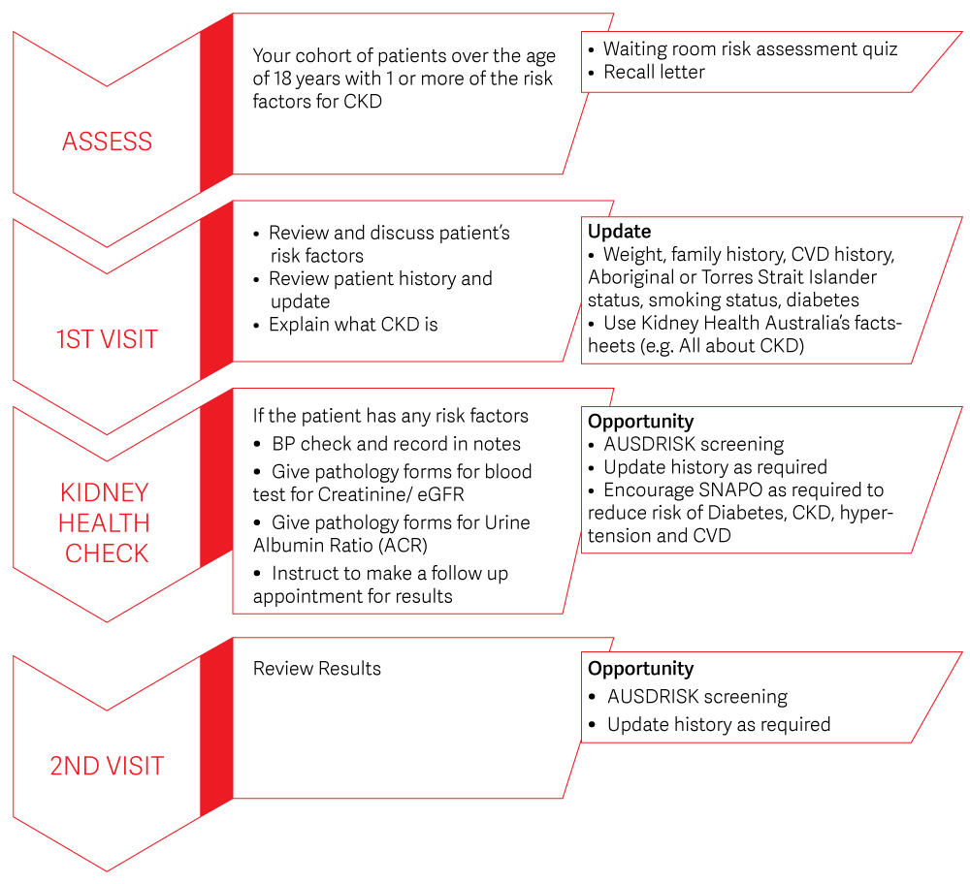
- Document any challenges as they arise.

Study
- Review the results of the DO part of the cycle by comparing initial data with current data.
- Identify what additional education or resources are needed to implement best practice CKD management for patients at risk or diagnosed with CKD.
For example:
- Further practice training.
- Better promotion of Kidney Health Checks.
- Utilise Kidney Health Australia resources (CKD Management handbook and CKD-GO! App).
- Kidney Health Australia accredited education.
- Was your cohort too restrictive, too broad?
- Identify any areas and challenges, barriers to success of this program and how to overcome them to implement in the 2nd cycle.

Act
- Implement identified actions and begin PLAN for the 2nd cycle.
- End of 2nd Cycle
  - Implement best practice CKD management for people with CKD
  - Implement a recall and reminder system for people with indicated CKD
  - Review data and analyse results – what changes have occurred because of the activity
  - Identify the mechanisms that have been put in place to promote reliable use of the improvement

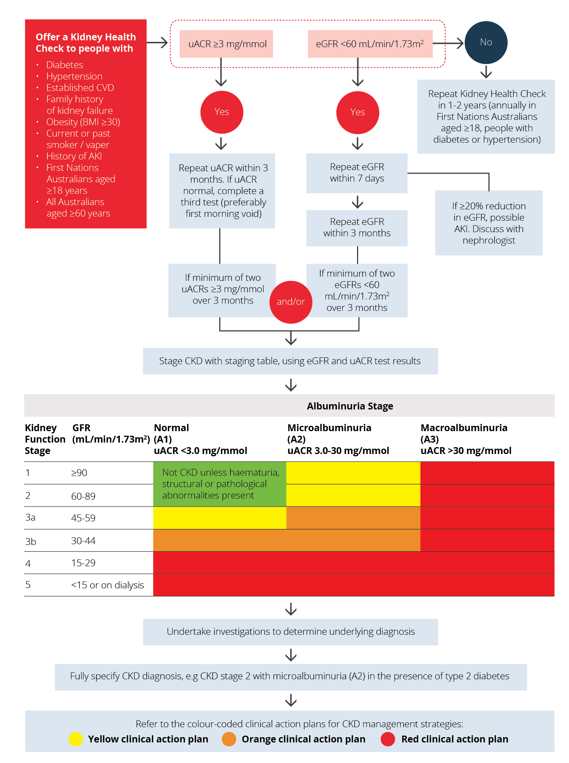








Connect with us:
Free call 1800 454 363
www.kidney.org.au
Prevent, Detect, Support, Research.

This program is copyright. Apart from any use as permitted under the Copyright Act 1968, no part may be reproduced without written permission from Kidney Health Australia. Requests and enquiries concerning reproduction and rights should be directed to kidney Health Australia PO Box 9993, Melbourne VIC 3001.

